**A WEB-BASED BLOOD BANK MANAGEMENT SYSTEM**

**BY**

**RAYMOND OGBIKO**

**2016/1/63974CT**

**DEPARTMENT OF COMPUTER SCIENCE**

**SCHOOL OF INFORMATION AND COMMUNICATION TECHNOLOGY**

**FEDERAL UNIVERSITY OF TECHNOLOGY MINNA, NIGER STATE**

**April, 2023**

# TITLE PAGE

**A WEB-BASED BLOOD BANK MANAGEMENT SYSTEM**

**BY**

**RAYMOND OGBIKO**

**2016/1/63974CT**

**DEPARTMENT OF COMPUTER SCIENCE**

**SCHOOL OF INFORMATION AND COMMUNICATION TECHNOLOGY**

**FEDERAL UNIVERSITY OF TECHNOLOGY MINNA, NIGER STATE**

**April, 2023**

# **DECLARATION**

I OGBIKO Raymond certify that the work detailed in this project report was completed under the direction of Dr. Abisoye Opeyemi Aderike in the Computer Science department. All of my assertions and conclusions are based on the results of my research. All relevant outside sources used for this study have been appropriately cited.

________________________ _____________________

OGBIKO Raymond Date

2016/1/63974CT

# **CERTIFICATION**

This document serves as proof that I OGBIKO Raymond, with matriculation number 2016/1/63974CT, completed the project entitled "A Web-Based Blood Bank Management System." In accordance with the guidelines of the Federal University of Technology, Minna, Nigeria, this project has been approved for the completion of the Bachelor of Technology in Computer Science.

__________________ ____________________

Dr. Abisoye Opeyemi Aderiike Date

Project Supervisor

__________________ ____________________

Dr. Abisoye Opeyemi Aderiike Date

Head of Department

__________________ ____________________

External Examiner Date

# **DEDICATION**

God, in His infinite greatness, has blessed me with the strength, wisdom, and grace to complete this undertaking. And to my wonderful parents, Mr and Mrs. Ogbiko, I dedicate this work.

# **ACKNOWLEDGEMENT**

I would like to express my sincere gratitude to all those who have supported me throughout my undergraduate final year project. This project would not have been possible without the guidance, encouragement, and support of several individuals and organizations.

I am deeply thankful to my project supervisors and Head of Department Dr. Abisoye Opeyemi Aderike, my lecturers in persons of; Mohammed Idris Kolo, John K. Alhassan, Dr. Solomon Adelowo Adepoju, Dr. Aminu Enesi Femi, Ugwuoke Cosmas Uchenna, Shehu Ibrahim Shehi, Dr. Abdullahi Muhammad Bashir, Dr. Ojerinde Oluwaseun Adeniyi, Falaye Adeyinka Adesuyi, Adama Ndako Victor, Muhammad Kudu Muhammad, Dr. Ameen Ahmed Oloduowo, Dr. Bashir Sulaimon Adebayo, Saliu Adam Muhammad, Dr. Abisoye Opeyemi Aderike, Dr. Mohammed Danlami Abdulmalik, Murtala Aminu Buhari, Ayobami Ekundayo, Lasotte Yakubu Boyi-Musa, Lawal Kehinde Hussein and Sani Alkali Umar, for their invaluable support, guidance, and encouragement throughout my course of this project. Their expertise in the field and their patience in explaining various concepts helped me gain a deeper understanding of the subject matter.

I am grateful to my friends Samuel Adeniyi, and family for their love, support, and encouragement, which kept me motivated throughout this journey. Finally, I would like to express my sincere thanks to all those who have directly or indirectly contributed to the successful completion of this project. Your efforts and support are greatly appreciated. God has blessed you all.

# **ABSTRACT**

*The web-based blood bank management system is a comprehensive platform designed to streamline the blood donation process and enhance the overall efficiency of blood banks. There is no mechanism in place to notify people when the blood supply drops below a certain threshold or when the expiration date of the blood is reached. Human mistake is possible at any point in the blood bank servicing process and could cause issues with blood administration. The National Blood Bank of Nigeria does not yet have a centralized database to store donor information. system aims to provide a user-friendly, secure, and efficient platform for managing the entire blood donation process, from donor registration to blood collection, testing, processing, and distribution. Donors could register online and schedule blood donations at their convenience using the proposed system. The system will securely store donor information in a centralized database, which could be accessed by authorized personnel for screening and testing. This system features an intuitive interface that simplifies the blood collection and processing procedures, ensuring accurate documentation of all blood products. The system uses HTML, CSS, JavaScript, and PHP language for its development. Results show that the blood bank management system has the potential to improve the accuracy and speed of blood donations, thereby saving lives and improving public health outcomes. The project represents a significant contribution to the field of healthcare technology and can be beneficial to blood banks and hospitals worldwide. The future works for this system is the Implementation of machine learning algorithms, and Integration with blood donation campaigns, and evaluation of the system's effectiveness in other hospitals and blood banks.*

# **TABLE OF CONTENT**

TITLE PAGE I

**DECLARATION** II

**CERTIFICATION** III

**DEDICATION** IV

**ACKNOWLEDGEMENT** V

**ABSTRACT** VI

**TABLE OF CONTENT** VII

**LIST OF FIGURES** X

**LIST OF EQUATIONS** XI

**LIST OF TABLES** XII

**LIST OF NOMENCLATURES** XIII

**CHAPTER ONE** 1

**1.0 INTRODUCTION** 1

**1.1 Background of Study** 1

**1.2 Statement of The Problem** 3

**1.3 Aim and Objective** 4

**1.4 Significance of The Project** 4

**1.5 Scope of The Project** 5

**1.6 Organization of This Report Document** 6

**CHAPTER TWO** 6

**2.0** **LITERATURE REVIEW** 6

**2.1 Blood Bank and Blood Bank Management System** 6

**2.2 Information System Development** 7

**2.2.1 Approach Based On Structured System Analysis and Design** 8

**2.2.2 An Approach to System Analysis and Design That Focuses On Objects** 8

**2.2.3 Modeling Techniques** 8

***a.*** ***Static (or Structural) View*** 9

***b.*** ***Dynamic (or Behavioral) view*** 10

**2.2.4 Modeling Procedure** 11

**2.2.4.1 The Waterfall Model** 11

**2.2.4.2 Iterative Model** 12

**2.3 System Architecture** 12

**2.3.1 Server-Based Architectures** 13

***Figure 2.1: Server-Based Architecture*** 13

**2.3.2 Client-Based Architectures** 13

***Figure 2.2: Client-Based Architecture*** 14

***Figure 2.3: Two-Tiered Client–Server Architecture*** 14

***Figure 2.4: Three-Tiered Client–Server Architecture*** 15

**2.3.3 Application Types Desktop Based Application** 15

**2.4 Related Publications and Works to A Web-Based Blood Bank Management System** 16

**2.4.1 Blood donation management system** 16

**2.4.2 Blood Donation System Based on Mobile Cloud Computing** 17

**2.4.3 KBase Life** 18

**2.4.4 Punjab Online Blood Bank Management System** 18

**2.4.5 A Knowledge Based System for Blood Transfusion** 18

**CHAPTER THREE** 20

**CHAPTER THREE** 20

**3.0 METHODOLOGY** 20

**3.1 Overview** 20

**3.2 Design Methodology** 20

**3.3 The Techniques** 21

**3.3.1 In-depth interview** 22

**3.3.2 Document review** 22

**3.3.3 Modeling Technique** 23

**3.4 Design an Architecture for the block bank management system** 23

**3.4.1. Blood Donor Reception and Registration** 23

**3.4.2 Pre-Donation Counseling and Medical Interview** 23

**3.4.3 IT-expert in-depth interview result:** 25

**3.5 System Design Models** 29

**3.5.1 System Class Diagram** 29

**3.5.2 System Architecture** 30

**3.6 Evaluation of The Project** 31

**3.7** **Operational Definitions** 31

**3.8 Ethical Clearance** 32

**CHAPTER FOUR** 34

**4.0** **RESULTS AND DISCUSSION** 34

**4.1 Overview** 34

**4.1.1 The Existing System** 34

**4.1.2 In-depth Interview** 34

**4.2 Proposed System** 35

**4.2.1 Context Diagram of the New BBIMS** 35

**4.2.2 Stakeholders** 35

**4.3 Analysis Models** 37

**4.3.1 Use Case Diagram** 37

**4.3.2 Use Case Narrations** 38

**4.3.3 ACTIVITY DIAGRAM MODELING** 40

**4.3.4 User Interface Prototype** 41

**4.4 System Requirements** 41

**4.4.1 Functional Requirements** 42

**4.5 Prototype Implementation** 43

**4.5.1 Flowchart Diagram** 43

**4.5.2 Presentation Layer** 44

**4.5.2.1. Donors Registry Form** 44

**4.5.3 Database Layer** 44

**4.5.3.1 Database Model** 44

**4.5.4 Middle Layer** 45

**CHAPTER FIVE** 47

**5.0** **CONCLUSIONS AND RECOMMENDATIONS** 47

**5.1 CONCLUSIONS** 47

**5.2 RECOMMENDATIONS** 47

**REFERENCE** 49

# **LIST OF FIGURES**

|  |  |  |
| --- | --- | --- |
| **Figures** | **Figure Description** | **Page** |
| 2.1 | Server-Based Architecture | 13 |
| 2.2 | Client-Based Architecture | 14 |
| 2.3 | Two-Tiered Client–Server Architecture | 14 |
| 2.4 | Three-Tiered Client–Server Architecture | 15 |
| 3.1 | The Organization Structure of National Blood Bank Center, Nigeria | 28 |
| 3.2 | Class Diagram for Blood Bank Management System | 30 |
| 3.3 | Architecture of The Blood Bank Information Management System | 31 |
| 4.1 | Context Diagram of the Blood Bank Management System | 35 |
| 4.2 | Database Setup of the Blood Bank Information Management System | 38 |
| 4.3 | The activity diagram for donation time slot reservation process | 40 |
| 4.4 | Home Page of the Graphical User Interface Prototype | 41 |
| 4.5 | Flow Chart diagram to represent basic function of the BBMS System | 43 |
| 4.6 | Donor Registry Form of the Graphical User Interface | 44 |
| 4.7 | SQL Sample Codes | 47 |
|  |  |  |

# **LIST OF TABLES**

|  |  |  |
| --- | --- | --- |
| **Table** | **Table Description** | **Page** |
| 4.1 | List of stakeholders and their responsibilities for the web based BBIMS of Nigeria, FCT, 2018 | 37 |
| 4.2 | Functional requirement list for the web based BBIMS of Nigeria, FCT, 2018 | 42 |
| 4.3 | Requirements Gathering Results | 47 |
| 4.4 | Database Schema | 48 |
| 4.5 | Blood Inventory Tracking | 50 |

# **CHAPTER ONE**

# **1.0 INTRODUCTION**

## **1.1 Background of Study**

The blood is the source of all of the oxygen and nutrients that the body needs to function. Science agrees that no living thing can survive without blood (Gebreegziabher, 2020). Due to numerous technological developments, individuals are now more likely to require a blood transfusion for their survival, support during recuperation, or maintenance of health (Fordham, & Dhingra, 2010). There is a constant demand for blood because to a variety of causes, including obstetric bleeding, car accidents, war, sickle cell disease, malnutrition, malaria, and parasitic infections (Bloch, *et al.,* 2012). In order to provide transfusions to individuals who need them, blood is collected, screened, stored, and delivered by a blood bank. Blood donation processing labs can be a component of a larger hospital complex, or they can be their own separate structure. Each year, the globe collects about 81 million units of blood, yet only 45 percent of those units come from developing and transitional nations, where 81 percent of the world's population lives (World Health Organization, 2010). As reported by around 8,000 blood centers in 159 countries to the World Health Organization (WHO), the average yearly collection per blood center is 30,000 in high-income nations, 7,500 in middle-income countries, and 3,700 in low-income countries, revealing significant disparities in the efficacy of blood collection across countries and income levels (Ifland, *et al.,* 2018).

Africa's current population of over 800 million requires roughly 8 million units of blood to meet transfusion demand, based on World Health Organization (WHO) standards of 10 units per 1000 people. The annual collection of 3 million units only covers about 40% of the expected need (3). Only 87,000 units of blood were donated for transfusion in 2015, despite Nigeria's annual need for around 200,000 units. As of 2015, this was documented by the Nigerian National Blood Bank. As of 2012 (Adenrele). When it comes to medical care, blood donation and transfusion are two of the most important components. Each government must ensure its people have access to a sufficient and safe blood supply at all times (World Health Organization, 2010). Lack of access to a reliable supply of quality blood is a major issue in many developing nations. Unsafe blood is a huge problem because of the severe safety concerns it raises and because there is a significant gap between the supply and demand of safe blood. One of the main obstacles to tackling these problems is the lack of trustworthy technologies to aid in the administration of blood programs. That's according to the WHO (2010), the World Health Organization.

The National Blood Bank of Nigeria is a non-profit governmental organization responsible for the management of blood and blood transfusion services in the country. The National Blood Bank's primary responsibilities include the following: community mobilization and education on voluntary blood donation; blood collection; laboratory processing, testing, and manufacture of blood; blood distribution to health facilities; the promotion of appropriate clinical use of blood; and the conduct of research and capacity building in blood transfusion services (BTS). A national blood transfusion service was established in 2005 by the Nigerian Red Cross Society (NBTS). Since 2010, the management of blood donors, blood collection, testing, and transfusion of blood and blood products has been entrusted to the Federal Ministry of Health. It is responsible for coordinating and overseeing the activities of blood banks located around the country but falling under the authority of different regional health ministries. Its headquarters are in the Federal Capital Territory (FCT) (Hamza, *et al.,* 2019 ; Williamson, 2000).

Given its new role within the greater health care delivery system, the Blood Transfusion Service (BTS) can ensure that all people have access to a reliable blood supply (Rad, *et al.,* 2022). The Federal Capital Territory is home to five of the thirty blood collection teams currently active around the country. From 2010 to 2014, voluntary blood donations increased from 10% to 98%. The FCT facility alone receives about 40,000 units from 100% voluntary blood donations, enough to satisfy the self-sufficiency requirement of 10 units/1000 of the population for a population of 2.5 million (Chevalier, *et al.,* 2016).

This project is being carried out to manage donors and donations, improve the blood bank's inventory management system, and reduce the disparity between the supply and demand of a safe blood supply.

## **1.2 Statement of The Problem**

Since "the cost of collection, processing, and distribution of information continues to fall," a growing number of technology-based applications have spread throughout several industries, including healthcare, as demonstrated by a case study on the Blood Bank information management system conducted in Kenya (Nzoka, & Ananda, 2022). Without an automated management system, it is challenging to know how many of each blood type are on hand, which blood group is running low, etc. There is also no mechanism in place to notify people when the blood supply drops below a certain threshold or when the expiration date of the blood in the bank is reached. In addition, no automated system exists for informing donors of the next gift deadline (Hashim, *et al.,* 2014).

Human mistake is possible at any point in the blood bank servicing process and could cause issues with blood administration. Eliminating incomplete or erroneous identification of patients or blood products and simplifying operations are two goals that should inform a systems approach to reducing errors. Systems that rely less on human data entry and double-checking in favor of more advanced computer technology stand to greatly increase productivity and accuracy (Porcella, & Walker, 2005). The National Blood Bank of Nigeria does not yet have a centralized database to store donor information. Blood banks do not share information with one another but instead maintain separate databases. As a result, it is difficult to track down donors who are technically new but have already registered with and donated at multiple blood donation centers.

While Guesh Dagnew's "a knowledge-based system for blood transfusion" aimed to collect blood transfusion expertise and establish a system to assist experts, this researcher has found no literature on Nigeria's need for a web-based blood bank management system (Dagnew, 2012). Thus, many problems arise when a blood bank does not have a web-based blood bank management system, including the need to register a single donor in multiple places, leading to data redundancy; improper stock management; an inability to automatically send directed promotion; and lengthy wait times for donors, even if they can reserve a time slot online.

## **1.3 Aim and Objective**

The aim of this project is to design a web-based blood bank management system for the National Blood Bank of Nigeria. In order to accomplish this goal, the outlined objectives are carried out:

1. To determine user and system requirement for the blood bank management system
2. To design an architecture for the block bank management system
3. To design a prototype of the blood bank management system including the user interface application design and development.
4. To develop an automated blood supply management system to monitor inventory levels, notify personnel of low supplies, and inform donors of upcoming donation deadlines.

## **1.4 Significance of The Project**

There are several benefits for blood banks, hospitals, and patients to use a web-based blood bank administration system. The system can enhance efficiency, which is especially important in emergency situations, by streamlining operations and decreasing the time it takes to locate and distribute blood products. Real-time access to data like as stock levels, donation records, and more can greatly improve openness. With this data, hospitals and blood banks will be able to better plan for the future and always have the blood products they need on hand. Donor management can be improved with the use of a web-based system because it simplifies tasks like data entry, tracking, and communication with donors. Donors can feel more connected to blood banks, which can lead to more donations. Last but not least, the system can improve safety by housing a consolidated database of donor and product information, which can aid in the fight against the spread of infectious illnesses and other risks related with blood transfusions. All things considered, a web-based blood bank management system can assist increase the efficacy, openness, and safety of blood banking operations, which is good news for both healthcare practitioners and their patients.

## **1.5 Scope of The Project**

This project to develop a Web-based blood bank administration system is limited to the development of the system's design and a test implementation. This means that we won't be moving forward with system-wide testing and implementation of the project. It will be housed at the National Blood Bank's headquarters, but being web-based, it will be accessible from anywhere in the world. In order to analyze and design the system, the development of this project uses object-oriented programming as its methodology, and this includes iterative process modeling. Methods based on the UML (Unified Modeling Language) for modeling are being considered. We'll be utilizing Visio and white star software to design prototypes of user interfaces. The prototype system will be developed with the help of the Hyper- Text Markup Language (HTML) and the Hypertext Preprocessor (PHP) programming languages for both the client and server sides. The database management system will be My- Structured Query Language (MySQL).

## **1.6 Organization of This Report Document**

The first chapter is an introduction; it contains information on the project's setting, the problem statement, the project's aims and objectives, its significance, and its scope. The second section is a literature review of the studies that have been conducted on this topic. Methodology for producing this paper is detailed in Chapter 3. System analysis and modeling, which can be found in Chapter 4, covered both the current system and how the new system is expected to operate. Chapter 5 provides a summary and recommendations.

# **CHAPTER TWO**

# **LITERATURE REVIEW**

# **2.1 Blood Bank and Blood Bank Management System**

Blood banking entails the processes of collecting, testing, preparing, and storing whole blood and blood components primarily for transfusion (Uddin, 2008; France, et al., 2013). Each step of the blood transfusion process, from collection to infusion, is the duty of a blood bank center, which is responsible for controlling, monitoring, and properly documenting the entire process (Li, *et al.,* 2007). To better manage donor and patient data, blood banks can use the Blood Bank Management System. Its major purpose is to store, process, retrieve, and analyze the blood bank's administrative and inventory data (Teena, *et al.,* 2014). The designated blood bank officer will have quick and easy access to all necessary donor and recipient data with a secure login and password. Furthermore, the experts do not consider the blood bank information management system to be obsolete, and in fact, it plays a vital role in attracting donors and other stakeholders due to its simplicity in donor appointment scheduling and recipient notification. In addition, anyone can visit any blood bank in the country and take blood for free from any of the local blood banks.

# **2.2 Information System Development**

All information systems consist of three distinct components: incoming data, intermediate results, and output data. This document stores the processing rules that will be followed during execution of the Information system. When processing rules are spelled out in detail, it paves the way for automated, computer-based information systems. However, if the processing rules call for a high level of expertise, judgement, and intuition, the associated information system will include instructions for use. Users should be able to trust in the reliability of a well-designed information system to both inform and lead them (Sulaiman, *et al.,* 2015). Information systems age much like every other manufactured good. Things like designing, building, releasing, running, and finally shutting down an IT system fall under this category.

Planning, prototyping, testing, and deployment are all stages in the process of creating new software (Hashim, *et al.,* 2014). When designing a new information system, a developer may draw on any number of tools, techniques, and guiding principles. Progress in Modeling as of Late Successful software releases rely on thorough modeling at every stage of the process. The goal of this document is to describe how a system should ideally look and function. To better understand the system we are constructing and to see where we may cut corners, recycle code, or mitigate risks, we build models to aid in the system's visualization and management of its design (Dudani, *et al.,* 2021). Users' creativity can be stimulated by having access to a model, which can be viewed as a collection of blueprints for the system. Structured and object-oriented modeling are two types of modeling that can be used in the development of information systems.

## **2.2.1 Approach Based On Structured System Analysis and Design**

In the world of software engineering, that is the standard operating procedure. In this approach, the process or function is considered the smallest possible software building block. Perspectives like this help programmer focus on control issues and the decomposition of complicated algorithms. Systems built using such an approach tend to be brittle. Systems that were built with an emphasis on algorithms are notoriously difficult to maintain as their needs and sizes change (Ekanayaka, & Wimaladharma, 2015).

## **2.2.2 An Approach to System Analysis and Design That Focuses On Objects**

Common consensus holds that the object-oriented paradigm is superior to other methods when it comes to assessing, designing, and developing application systems, especially for large-scale endeavors. In this framework, an issue is examined by isolating its constituent elements and tracing their interrelationships. Systems built using the objective-oriented paradigm are more malleable. Adding new object types or modifying existing ones is a breeze with such systems (Esmail, & Osman, 2018).

## **2.2.3 Modeling Techniques**

In order to convey complex ideas in a clear and succinct manner, notations are used. Misunderstandings are extremely expensive, especially in large-scale projects with many players and a wide variety of technical and cultural backgrounds (Kayode, *et al.,* 2021). As the standard language for object-oriented programming, UML is used to describe, visualize, construct, and document software products (Amidhayan, 2018). When representing system analysis and design, UML uses a number of different diagramming styles. The two main categories for system modeling viewpoints in UML's nine defined artifacts are "design" and "implementation.".

## ***Static (or Structural) View***

The rigidity of the system's design is emphasized by this viewpoint's attention to objects, characteristics, operations, and relationships. Elements that cannot be changed include use cases, classes, packages, components, and installation diagrams.

1. **Use Case Diagram:** Use case diagrams highlight the interaction between the system and the actors (objects outside the system that interact directly with it). It offers a treasure mine of real-world applications and the associated third parties. Putting it plainly, a use case is an abstract, high-level representation of a transaction that involves numerous system objects. Use cases are represented by ellipses, and the symbols for the various actors are connected to those cases via lines that are always connected. Visualizing the scope and limitations of a system and its behavior can be achieved with the help of a use case diagram. The use cases represented by a use case diagram can be described in narrative form (Zakaria, *et al.,* 2020).
2. **Class Diagram:** The class diagram reveals the fixed arrangement of the system's components. In here, you'll find a complete catalog of the classes that will be employed in the proposed system, along with descriptions of their properties, methods, and interclass interactions. Connections can take many forms, including inheritance, membership, and summarization. According to a recent study (Abu-Naser, *et al.,* 2016),
3. **Component Diagram:** An element diagram provides a visual depiction of the system's physical components. It aims to show how the system's software components interact with one another (Asianuba, & Ubom, *et al.,* 2021). A part of an architectural specification, it is created by architects and developers.
4. **Deployment Diagram:** A deployment diagram is a graphical depiction of how a system is implemented in a real-world hardware environment. The purpose of this diagram is to show how the different components of the system are physically connected to one another. System engineers, network architects, and application developers use it to pinpoint bottlenecks in a running system (Yuan, *et al.,* 2016).
5. **Package Diagram:** Classes are grouped together into packages, the structure of which can be shown in the package diagram. Assembling your model's constituent parts into manageable packages is made possible via UML. This will make your UML diagrams easier to read and understand (Khan, & Qureshi, 2009).

## ***Dynamic (or Behavioral) view***

To illustrate the intrinsic volatility of a system, behavioral diagrams typically depict interactions between objects and changes to the objects' internal states. A dynamic element is one that is in a constant state of change. These dependent and malleable parts can be seen in a variety of sequential, cooperative, state chart, and activity diagram formats. In a recent study (Ayeni *et al.,* 2019).

1. **Activity Diagram:** The control flow of an active diagram can be used to represent the transformation of an object between states. It's a simplified flowchart emphasizing the order of occurrences. Activity diagrams can model both high-level business process at the business unit level and granular internal class actions. People in the business world have an easier time getting their heads around it since it appears "Less technical" than sequence diagrams (Deshpande, *et al.,* 2020).
2. **Sequence Diagram:** Due to its ability to depict the temporal connections between various entities, a sequence diagram is a helpful tool for understanding time constraints. It illustrates an end-to-end process for one use case or a special case of a use case (Deshpande, *et al.,* 2020). A sequence diagram is a visual representation of the flow of data from one component to another. Its main use is to show the sequence of operations that a system goes through to complete a task.
3. **Collaboration Diagram:** Collaborative diagrams are used to obtain a sense of the program's flexibility. Collaboration diagrams show how information moves from one object to another in an OOP program, and can provide some insight into the basic linkages (relationships) between classes (Tebandeke, *et al.,* 2022). Like sequence diagrams, collaboration diagrams help explain how different parts of a system work together. A collaboration diagram, on the other hand, is used to display relationships and organizational structures.
4. **State Chart Diagram:** A class's transitions between states are depicted on a state chart. Though state chart diagrams are useful for any class that has a state (a condition being met, an action being performed, or a state of waiting for an event to occur), this is not always the case (Deshpande, *et al.,* 2020). Reactive, event-oriented, and lifecycle objects are all represented in state chart diagrams (user interface, devices, etc). The nine artifacts provided by the UML for system modeling each offer a unique vantage point.

## **2.2.4 Modeling Procedure**

Projects are carried out according to predetermined sequences of actions, which are modeled after procedures. Several distinct modeling approaches have been successfully implemented in the software engineering process. There are many other methodologies used in software development, but the Waterfall and Iterative/Incremental approaches are the most common.

## **2.2.4.1 The Waterfall Model**

The Waterfall Model is the industry standard when it comes to SDLC (software development life cycle) frameworks. This is a common model used by the government. The sequential nature of the processes in this paradigm is what sets it apart. It all starts with asking for feedback and concludes with fixing bugs (Azhar, & Ali, 2022). The waterfall model differs from other approaches in that its stages do not overlap but rather flow sequentially from one to the next. There is no room for maneuver in this approach to accommodate unforeseen changes (Boonyanusith, & Jittamai, 2010). This method, which places a premium on planning and record-keeping, works well for projects where strict quality control is of paramount importance (Kumar, & Suneja, 2021). The waterfall methodology encompasses the phases of defining the project's scope, gathering requirements, designing the solution, developing the solution, testing it, and finally maintaining it.

## **2.2.4.2 Iterative Model**

Understanding the full scope of a project's requirements might be challenging in the outset. When developers don't successfully implement user feedback, it hinders users' ability to share their thoughts. When creating software systems, iterative development takes a methodical approach. An initial, rudimentary implementation of some portion of the software requirements is followed by incremental improvements until the entire system is in place. Although the initial release meets the minimum requirements and serves as a foundation for the final product, numerous supplementary features, both known and unknown, are still outstanding. Variations typically introduce new features and refine existing ones. This method allows the programmer to apply their findings as they create increasingly stable system iterations (Nzoka, M., & Ananda, 2022). Since it can be risky to build an entire system at once, this method is particularly useful for projects involving cutting-edge technology, as it eases people into the system gradually (Ismail, *et al.,* 2021).

# **2.3 System Architecture**

Information system components and their distribution over several computers, as well as the hardware, operating system software, and application software that will be used by each machine, are all aspects of the network environment that are addressed by the system design. The deliverables include the architectural design and hardware/software requirements. Different system architects were used by various software.

## **2.3.1 Server-Based Architectures**

Each of these four stages of an application's life cycle—presentation logic, application logic, data access logic, and data storage—are handled by the server (often a centralized mainframe computer). Users were able to communicate with the server computer via the clients (often terminals) (Priya, *et al.,* 2014).

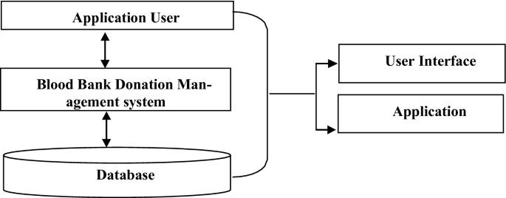

## ***Figure 2.1: Server-Based Architecture***

## **2.3.2 Client-Based Architectures**

In client-based designs, microcomputers on a LAN are referred to as "clients," whereas a server on the same LAN is referred to as "server." The software running on client computers serves as those machines' "brains," or "control system," for handling presentation logic, application logic, and data access logic. The server stores information and does nothing else (Priya, *et al.,* 2014).

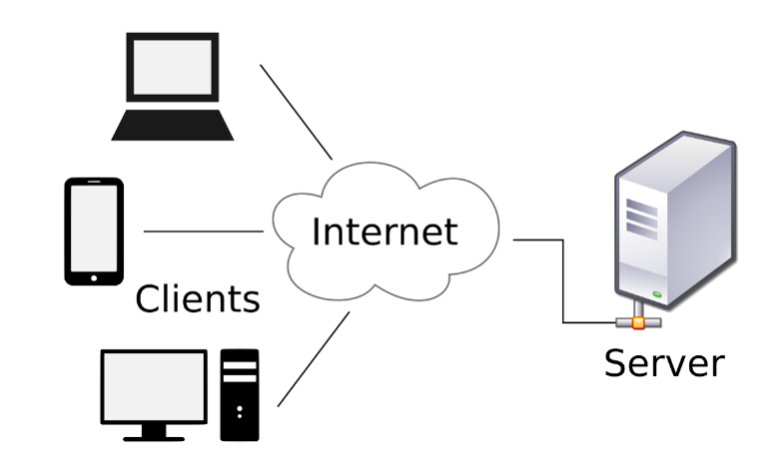

## ***Figure 2.2: Client-Based Architecture***

The current architectural gold standard, it optimizes productivity by dividing tasks between clients and servers. In such architectures, the client is responsible for presentation while the server is in charge of data access and storage. The application logic could be hosted either on the client or on the server, or it could use a hybrid architecture. These layouts can be adjusted to fit a variety of client and server setups (Kaur, *et al.,* 2022). One of several options for distributing app functionality between clients and servers. This is how it typically appears:

1. **Two-Tiered Architecture**

In this configuration, the server is in charge of the data while the client is responsible for the application and the display.

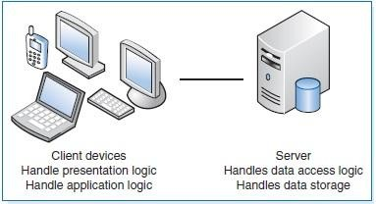

## ***Figure 2.3: Two-Tiered Client–Server Architecture***

1. **Three-Tiered Architecture**

Client-side software is responsible for the display logic in this architecture, while one or more application servers handle the logic behind the applications themselves and the storage and retrieval of data. In most cases, a graphical user interface (GUI) on a desktop or workstation is used as the interface. The application's logic may be broken up into different modules, depending on its specifics. Information retrieval and storage are ultimately handled by a relational database management system (DBMS) running on a server.

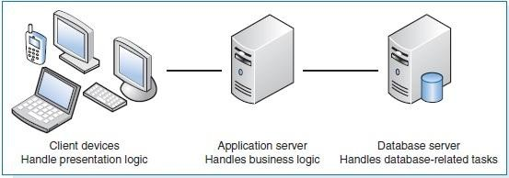

## ***Figure 2.4: Three-Tiered Client–Server Architecture***

## **2.3.3 Application Types Desktop Based Application**

It's a native program because it's designed to work entirely with the user's local PC. This software can only be used by one person at a time. Historically, desktop apps have been limited in functionality due to the hardware they run on. They are incompatible with any other operating system and typically have high hardware requirements that must be met before the program will operate. Users are responsible for updating their own installations of the software, which may require new hardware or other configuration changes (Pratyusha, *et al.,* 2021).

1. **Mobile Based Application:** A computer application designed for use on a mobile device. Software on today's smartphones and tablets can connect to distant services using the device's cellular data connection or web browser, allowing these services to make changes to the device's data or display.
2. **Web-based System Development:** It's a piece of software that makes use of internet-accessible data storage and computing capability (34). Information may now be gathered, organized, disseminated, processed, and consumed in unique ways thanks to the World Wide Web (Maji, *et al.,* 2018). In addition, developers can take advantage of the media capabilities of existing web browsers to create more interactive, media-rich user experiences. A web-based solution is easy to expand, modify, and utilize across multiple devices.

# **2.4 Related Publications and Works to A Web-Based Blood Bank Management System**

While a wide range of sources (books, journals, etc.) were reviewed for this project, just a subset of the most relevant articles and books are included here.

## **2.4.1 Blood donation management system**

There is an internet platform called Blood Donation Management System and a mobile app to go along with it that are meant to facilitate communication between patients (who need blood) and blood donors. The method was designed at Jahangirnagar University in Dhaka, Bangladesh (Rajapakse, 2015). The hope was that by offering an online advantage for matching donors and users of blood, this system would foster a cooperative network between blood donors, patients in need of blood, and blood bank clinics. For donors to utilize the system, they must first build a profile by providing information about themselves, including their name, blood type, email address, password, and precise location using "Google Map." This app integrates with Google Maps so that users may easily pinpoint the precise location of potential donors (Herman, D. A., & Wijaya, 2022).

Donor whereabouts are updated in real time via the app on your smartphone. This means that the system can track down a registered donor no matter where they may be. The homepage allows you to search for blood donors based on your blood type and proximity to you. Donors' contact information, including phone numbers, email addresses, and physical locations, is listed in the system, and can be accessed in a variety of ways, depending on factors like their geographic (Nabil, *et al.,* 2020). The trial was successful, even though the researchers haven't yet built the mobile software that will enable multimedia cell phone users to locate a blood donor using a map interface.

## **2.4.2 Blood Donation System Based on Mobile Cloud Computing**

The Kingdom of Saudi Arabia intends to set up and run the Blood Donation System, so that people can donate blood when they need it (BDS). Cloud computing (CC) and mobile computing (MC) make up the system's two main components (Nazar, & Sari, 2019). Creating a mobile-friendly, cloud-based infrastructure for blood donations was the primary focus of this study. Using mobile technology and the cloud for backup, the Blood Donation System (BDS) is a database that greatly improves the donor experience.

The system's intention is to combine the different blood-related databases now existing within hospitals and other health institutions, and to simplify the process by which blood donors and collection facilities can share information with one another. Donors and others involved in the process used a mobile app to monitor their whereabouts and statuses. The app's users can receive notifications about urgent requests for blood donations, check their eligibility to donate, find the closest donation center, and set up a convenient appointment time all through the use of time and/or location data (Alamgir, & Mohamed, 2022). According to the results, the team settled on a framework that consists of a cloud computing component, which represents the cloud with all its service models and provides all blood donation services to stakeholders in the mobile computing environment, and a mobile computing component, which represents the mobile environments where the blood donation stakeholders interact with and gain support from the cloud element.

## **2.4.3 KBase Life**

Information about blood banks can be stored in the KBase Life database. This system is a web-based blood bank management tool used for overall control. It can be used to keep tabs on and control everything from the component's initial conception through its final infusion. This system oversees not just the administrative tasks of the blood bank (such as human resources, finance, and billing), but also its health education and awareness initiatives. This system is used by Malaysia's National Blood Bank (Pratyusha, *et al.,* 2021).

## **2.4.4 Punjab Online Blood Bank Management System**

Online blood bank management system for tracking administrative and stock information (Andriani, *et al.,* 2022). In addition to handling blood donation camps and camp organizers, donors, inventory, blood demand and issuance, online blood transfer between blood banks, and the disposal of expired or unsuitable blood, the Punjab online blood bank management system offers many more functions. The user has the option of searching for blood donors either geographically or by blood type. Moreover, the system generates a variety of report formats (Al-Ma'mari, *et al.,* 2019).

## **2.4.5 A Knowledge Based System for Blood Transfusion**

To improve efficiency, the Nigerian federal blood bank decided to invest in this software. The system's objectives included researching blood transfusions and building a database of relevant information that may be used to advise practitioners in the field. The patient's blood and the transfused blood are cross-matched by the technology. Using a rule-based knowledge representation technique, this research modeled the relationship between facts and rules. The findings show that the system understands the blood transfusion process overall to the tune of 83.3%. This system can be used by blood banks as part of their overall information management system (Dagnew, 2012; Rad, *et al.,* 2019).

# **CHAPTER THREE**

# **METHODOLOGY**

# **3.1 Overview**

The project is taking place in the nation's blood bank in the Federal Capital Territory. The National Blood Transfusion Services (NBTS), which was established in 2005 by the Nigerian Red Cross Society, is in charge of managing blood donations and transfusions in Nigeria. The Federal Ministry of Health in Nigeria has been in charge of the national blood bank since 2010. This ministry is responsible for a variety of duties, including but not limited to: community mobilization and education on voluntary blood donation; management of blood donors; collecting, testing, and transfusion of blood and blood products in Nigeria; promotion of the right clinical use of blood; and research on and capacity building for BTS. Over a hundred employees are employed at the national blood bank, and their backgrounds span from medicine and IT to management and administration. It is responsible for assisting and monitoring the nine regional and two municipal administrative blood banks across the country, all of which report to the FCT in the capital. Medical centers submit their data to regional health departments.

# **3.2 Design Methodology**

The fundamental objective of implementing new information systems within a company is to improve operational efficiency. The success of this endeavor is contingent on several variables, such as the efficiency of the information system, the effectiveness of the organization's procedures and processes, the competence of its personnel, and the care with which its design and rollout were handled (Maji, *et al.,* 2018). Perspectives from both natural (or behavioral) science and design science, which are distinct but complementary, can be found in the topic of information systems. The behavioral science paradigm seeks to construct and validate theories (i.e. principles and laws) to explain or foresee organizational and human events surrounding the study, design, implementation, and use of information systems. The stated goal of an information system is to boost an organization's efficacy and efficiency, and these ideas educate scholars and practitioners on how to manage the interplay between humans, machines, and institutions. With the right approach, any issue can be corrected, and that's the paradigm design scientists operate under. Creating new ideas, methods, tools, and services to improve information systems' analysis, design, implementation, management, and end-user experience is its primary mission (Herman, & Wijaya, 2022). The six steps of the Design Science process are: (1) identifying a problem and being motivated to discover a solution; (2) defining success; (3) developing a strategy; and (4) putting the strategy into action; and (5) testing, demonstrating, and communicating the outcomes (Rajapakse, 2015).

Therefore, design science was employed as a methodology for this undertaking since it is a paradigm that seeks to innovate beyond the boundaries of what is currently possible for both individuals and businesses. Object-Oriented analysis and design are used to create the system. This approach was selected due to the advantages listed in Section 2.1.3.2, including the researcher's familiarity with the Object-Oriented technique and the program's modularity, extensibility, reusability, and maintainability.

# **3.3 The Techniques**

To guarantee that all necessary information is acquired for system development, numerous different requirement elicitation approaches are at your disposal. Methods for analyzing both user and system requirements are outlined.

## **3.3.1 In-depth interview**

The in-depth interview is the method of choice for the researcher since it yields the most relevant data and allows for the freest expression of some relevant nuances not possible in other data gathering settings. These interviews are with the national blood bank's manager, two laboratory technologists, and an IT expert. Since this is a qualitative study, we are not concerned with the sample size (though some qualitative studies do recommend a certain minimum) and these are the only people working as a team leader on the specific area that this project aims to address, we have decided to limit the size of the team to four members. All volunteers had at least a four-year degree before being selected. Participants were surveyed about the kind of systems they use, their potential needs, and their past exposure to management in an organization. The in-depth interview is conducted in a separate room so that interviewees can remain anonymous. The aforementioned transcribing method was used to assess the substance of each participant's response, guaranteeing that no key details were lost in the transition from oral to written form.

## **3.3.2 Document review**

Along with the interview, information is acquired through a review of the forms and other material regularly used by the center. Through this examination, the investigator learns what sorts of documents are held at the National Blood Bank Center and which ones are most relevant to the BBMS. The project's scope included a review of donor registration forms, blood distribution forms, blood disposal forms, and other comparable papers for routine data recording, compilation, processing, and reporting. In order to acquire a document like a blood disposal form, the investigator need first get permission from the appropriate body.

## **3.3.3 Modeling Technique**

The analysis and design of the system are modeled using the UML notation. Construct a Case Study and Explain Its Use The analysis phase of the system model makes use of tools like Use Cases to define the scope of the system and Activity diagrams to depict the movement of an item as it moves from one state to another along the flow of control. A class diagram is a graphical representation of the system's architecture that shows the relationships between the various classes and their individual components. The UML approach was selected because of the Object-Oriented Support and the knowledge of the investigator.

# **3.4 Design an Architecture for the block bank management system**

Expert interviews revealed that different methods and locations are used to draw blood at the center at the present time. It collects blood both at the central blood bank's headquarters and from mobile case teams that travel to various locations to host blood donation drives. It takes about 45 minutes to complete the entire blood donation process from registration to refreshments. Follows are the procedures that were supposedly followed during blood collection, as described in the interview:

## **3.4.1. Blood Donor Reception and Registration**

General data (name, address, phone number) is collected in the lobby. All donors must produce identification in order for us to keep accurate records of who gave what. At this point, the receptionist nurse and several brochures will provide interested donors with the correct pre-donation information they need. Here, too, a donor questionnaire is provided to potential donors to determine their suitability to receive organs.

## **3.4.2 Pre-Donation Counseling and Medical Interview**

The nurse performs a brief physical examination, takes a medical history, and offers pre-donation counseling. The donor's vitals, including weight and blood pressure, will be measured and recorded throughout the examination. The donor's iron-carrying red blood cells will be counted after a small sample of blood is drawn from a vein in the donor's finger. The donor will be requested to sign a consent form after receiving information about the services they would receive after donating.

1. **Donation**

In the actual donation area, a phlebotomist will clean the donor's arm where blood will be drawn. Less than ten minutes are needed for the actual donation, which yields about a pint of blood. Everything that goes into the contribution is individually wrapped, hygienic, and disposable. They are single-use items that are thrown away after usage. During this time, the phlebotomy nurse will provide the donor with pre-donation education.

1. **Refreshments and Relaxation**

Donors are shown to a resting area with refreshments after giving blood. Donors are free to leave the cafeteria and return to their regular routines after 15 minutes.

1. **Post Donation Counseling**

To preserve the microbiological safety of the blood supply and to certify that the donation is safe to be utilized for therapeutic reasons, it is imperative that every donated blood be analyzed for indicators of Transfusion-Transmissible Infection (TTI). Blood screening assays often have excellent sensitivity; however this is at the expense of specificity, and false-reactive responses can arise. Donors with reactive screening results should undergo confirmatory testing to identify infectious donors or donors with nonspecific reactivity or inconclusive results before being informed, contacted, and advised about their infectivity status. Donors whose TTI test results are out of the ordinary or atypical should be referred for counseling as part of any comprehensive donor service and care program. If a donor is found to be contaminated, they must be informed of this fact, counseled, prevented from donating blood, and directed to receive the necessary medical attention.

It is important to inform, comfort, and coach donors who repeatedly test reactive in screening but who then test negative in confirmatory testing, and to temporarily postpone them until they test non-reactive. Once this is proven to be false, they will once again be eligible to donate blood. The donor should be informed, counseled, and deferred temporarily, typically for up to six months, if the results of confirmatory tests are ambiguous. They will be eligible to donate blood in the future if they have a negative screening and follow-up. Expert interviews on the current software also revealed the existence of a database application in which laboratory technologists previously recorded data on blood samples that were discarded.

## **3.4.3 IT-expert in-depth interview result:**

In-depth questions about the national blood bank's current software, hardware, network architecture, and reporting processes were posed to a local IT specialist working as the data manager for the institution. The findings from the interviews were broken down into the following sections.

1. **Software**

The facility is now utilizing an MS-SQL database management system-based database application. The center uses the database to keep track of who donates blood, how much is collected, which hospitals get it, who gets screened for it, and which ones don't need it. As an added bonus, the center can use the data stored in the database to produce reports. Unfortunately, as the data manager pointed out, the database lacks a user-friendly interface. Further, the center lacks a web presence, which is crucial for announcing various campaign events and raising awareness about the importance of voluntary blood donation across the country.

1. **Hardware**

The National Blood Bank Center has a wide variety of computer hardware devices throughout its several divisions. Due to a lack of data regarding the center's hardware, the investigator, in conjunction with the data manager, conducted a hardware inventory. Each of the center's case teams conducted the inventory, which focused mostly on IT infrastructure. Therefore, 30% of the computers are rather old and have low specs, especially when it comes to memory, hard drive space, and processing speed. The center also appears to rely on an antiquated and inadequate Compaq desktop computer serving as a server, with only 160GB of hard disk space and 512MB of RAM available for use. For a full list of items, please refer to Appendix B.

1. **Network Infrastructure**

There are currently no more than 15 users on the network that links the data center to the various departments within the National Blood Bank Center. At its core is a set of plug-and-play light switches (not configurable). As a result, there is a lack of centralized management that hinders effective resource utilization and administration. The data center utilizes an ADSL broadband connection with a 3MB bandwidth, as stated by the center's data manager.

1. **Manager in-depth interview results:**

According to the interview, the National Blood Bank directly manages its headquarters and provides guidance and resources to the other twenty-four blood bank facilities located across the country. Core operations at the National Blood Bank Center include blood collection, laboratory processing, testing & manufacture of blood, and delivery to health facilities. The center gathers data from other centers and distributes it to those who can use it. When I asked the manager if the blood bank used a reservation system to ensure that donors were able to schedule appointments in advance of their visits, he said that they did not have such a system in place and could benefit greatly from a web-based reservation system that would allow donors to schedule appointments at their convenience.

According to the manager, "we have a plan to get a software application that helps us on the management of the blood bank inventory as well as achieve our goals on community mobilization & education on voluntary blood donation" is part of the National Blood Bank's strategy for meeting its goals through various means, such as using software applications.

There are supposedly 282 people working in the various teams and divisions of the National Blood Bank Center, according to the management. Figure 4.1 depicts the organizational structure, which provides an overview of the organization through its component parts. The project's primary focus has been in the fields of information technology and laboratory and medical services, so that's where we'll start.

1. **Information Technology**

One data manager and five data encoders work for the National Blood Bank Center's IT department. It is their job to keep track of all the data generated by the collection, processing, and distribution of blood and blood products, including the details of individual donors. Additionally, they liaise closely with each division to guarantee accurate documentation and management of all donor data. This section is responsible for compiling weekly, monthly, and yearly reports on the national blood transfusion service's efficiency. In addition, there is a single receptionist working beneath the lobby who welcomes visitors, takes their information, and verifies their eligibility to donate blood.

1. **Laboratory and Medical Service Directorate**

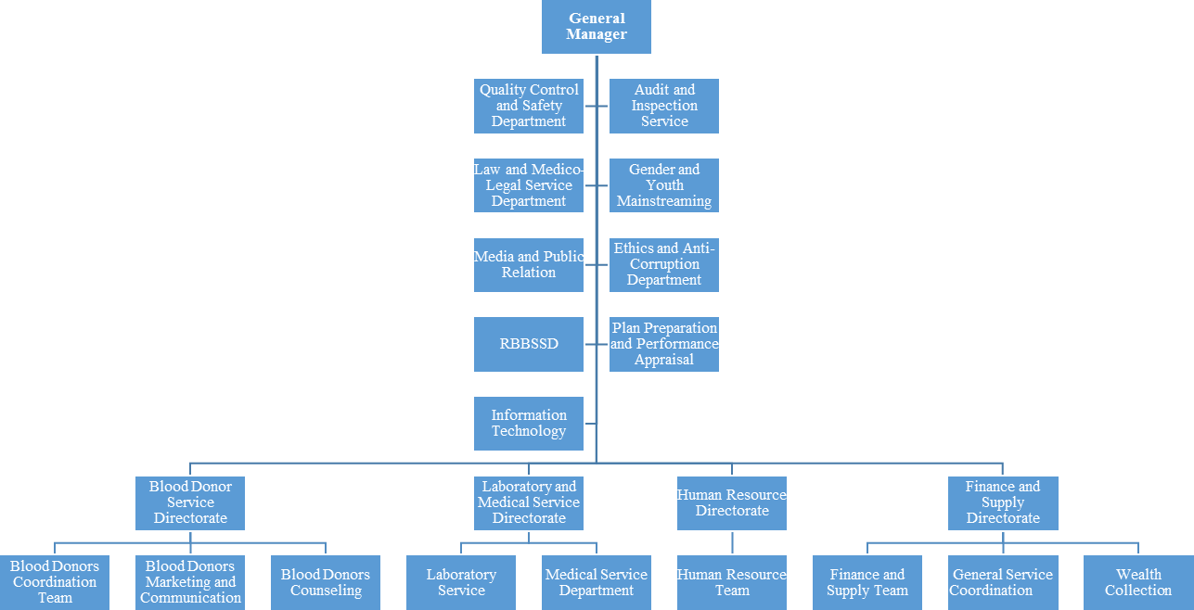The Laboratory Service Department and the Medical Service Department fall under the purview of this directorate. There are a total of 31 workers in the laboratory service division. Their job is to ensure that hospitals have access to healthy blood by testing it for potentially transmittable viruses including HIV, HBV, HCV, and syphilis, typing the blood, and preparing blood components like concentrated red cells, fresh frozen plasma, platelets, and cryoprecipitate. The lab contains case teams for ABO blood typing, infectious disease testing, and tissue component processing.

Figure 3.1: The organization structure of national blood bank center, Nigeria (May, 2018)

The investigation involved the examiner looking at a wide range of papers. With the help of this review, the investigator was able to better understand the purpose of these documents, the information they include, and the gaps that exist (such as the issue of having a combined donor registration form and blood registry form, or the reporting format not providing blood-specific (O,A,B,AB) output). Formats for registering donors, distributing blood, discarding blood, and reporting are all now in use at the blood bank. The bank's current forms can be found in appendix E at the conclusion of this page.

# **3.5 Developing an Automated Blood Supply Management System to Monitor Inventory Level**

The automated blood supply management system aids to monitor inventory levels, notify personnel of low supplies, and inform donors of upcoming donation deadlines, and this is achieved with the following approach processes:

## **3.5.1 Requirements Gathering**

The first stage involved gathering requirements for the system from stakeholders, including hospital staff, blood bank personnel, and donors. The requirements were collected through a combination of interviews, surveys, and observation of current processes. The requirements were documented and prioritized based on their importance.

## **3.5.2 System Design**

The system design stage involved creating a high-level architecture, defining the modules and interfaces, and selecting the appropriate technology stack. The system was designed to support the requirements gathered in the previous stage. The design included a user interface for hospital staff to monitor blood inventory levels, automated notifications for when supplies ran low, and a donor portal for informing donors of upcoming donation deadlines.

## **3.5.3 Database Design**

The system requires a database to store information about blood inventory, donors, and recipients. The database was designed to support the data requirements, including data types, relationships, and access controls. The database design was informed by the system design and requirements gathering stages.

## **3.5.4 Development**

The development stage involved building the system in an iterative and incremental manner. The development process followed best practices for software development, including code reviews, testing, and documentation. The development process used an agile approach, with sprints lasting two weeks. Each sprint added new features and improved existing ones.

## **3.5.5 Testing**

The testing stage involved ensuring that the system met the requirements and was free of bugs. Testing included functional testing, integration testing, and performance testing. The testing process followed best practices for software testing, including using automated testing tools and manual testing by human testers.

## **3.5.6 Deployment**

The deployment stage involved deploying the system to a production environment. The deployment process followed best practices for software deployment, including version control, automated deployment, and rollback procedures. The deployment process was carefully planned and tested to minimize downtime and ensure a smooth transition to the new system.

## **3.5.6 Maintenance**

The maintenance stage involved monitoring the system for issues, fixing bugs, and making updates as needed. Regular backups were taken to ensure that data was not lost in the event of a system failure. The maintenance process followed best practices for software maintenance, including using a ticketing system to track issues and using version control to manage updates.

In summary, the methodology for developing an automated blood supply management system involved gathering requirements, designing the system, developing it in an iterative manner, testing it thoroughly, deploying it following best practices, and maintaining it over time.

# **3.6 System Design Models**

## **3.6.1 System Class Diagram**

The researcher utilized a class diagram from the Unified Modeling Language to represent the system's architecture. The class diagram for BBIMS lays out all of the classes and describes how they are connected, what their properties are, and how they are used. The "User-Account" class was discovered, from which the "User" class and the "Administrator" class both inherit. The administrator oversees the "Donor" and "Center" classes. Information about Blood and users is stored in the Registration class. An individual can change the "Report" class whichever they like. Attributes and classes are determined based on the analysis of source documents. For a class diagram of a blood bank IMRS, see Figure 3.2. This Class Diagram for a Blood Bank Management System consist of several classes representing different entities in the system. These classes include Donor, BloodUnit, Recipient, Hospital, Organization Admin, Inventory Manager, Lab Technician, and Nurse. The Donor class represent blood donors and their attributes, such as donor ID, name, contact information, blood type, and donation history. The inventory manager class represent individual units of blood stored in the blood bank's inventory, with attributes such as blood type, expiry date, and availability status. The Recipient class represent blood recipients and their attributes, such as recipient ID, name, contact information, and transfusion history. The BloodBank class would represent the blood bank as an entity, with attributes such as blood bank ID, name, location, and contact information. The Staff class would represent the staff members working in the blood bank, with attributes such as staff ID, name, role, and contact information. These classes would be interconnected through relationships such as associations, aggregations, and dependencies, depicting how they interact with each other in the Blood Bank Management System and providing a visual representation of the system's overall structure and data flow.

**Receptionist**

Name

Phone_Number

Email

Address

Register_donor()

**Donor**

Name

Age

Email

Phone_Number

Address

Donate()

Register_for_camp

**Blood**

Blood_Type

Code

Info

Price

Add()

Subtract()

**Inventory_Manager**

Name

Phone_Number

Email

Address

Process_Orders()

Accept_Blood()

Reject_Blood()

**Organization_Admin**

Name

License_Number

Register Staff()

**Hospital**

Name

Phone

Fax

Foundation_Date

Order_Blood()

Purchase_Blood()

Reject_Blood()

**Lab_Technician**

Name

Phone_Number

Email

Address

Test_Blood()

Accept_Blood()

Reject_Blood()

**Nurse**

Name

Phone_Number

Email

Address

Barcode_Blood()

Register

Manages

Order_Blood_From

Tests

Register

Figure 3.2: Class Diagram for Blood Bank Management System

## **3.6.2 System Architecture**

The system's architecture is a detailed breakdown of its components, including its hardware, software, and network. In terms of structure, the BBIMS is a three-tier client-server system. Most modern systems employ some version of the client server design, which aims to distribute processing load evenly amongst multiple client devices and one or more server devices. Presentation logic is handled by client-side software, application logic is handled by one or more application servers, and data access logic and storage are handled by one or more database servers in a three-tier architecture (31). The researcher suggested using such an architecture for the project due to its scalability and ability to accommodate a wide variety of client and server configurations. The information management system for a blood bank is shown in Figure 4.7, which depicts the system's client/server architecture. This number A blood bank information management system's design typically consists of several parts that cooperate to control the donation and distribution of blood. Users can engage with the system through the front-end user interface by registering as donors and submitting blood requests, for example. The essential system operations, such as blood inventory management, data storage, request processing, and business logic implementation, are handled by the back-end server. Relevant data, including donor and receiver details, blood unit specifics, and test results, are stored and managed via a database management system. Together with controlling inventory levels, expiration dates, and availability status, a blood inventory management component guarantees effective management of blood units. These elements cooperate to improve blood donation and distribution procedures, streamline blood bank operations, and make sure that patients in need may access safe and compatible blood.

**ADMIN**

**ADMIN**

**BLOOD BANKS**

**HOSPITAL/USERS**

**LOGISTICS**

Figure 3.3: Architecture of The Blood Bank Information Management System

# **3.7 Evaluation of The Project**

After the system's design and development of a prototype were finished, the system's usability was tested by subjecting it to a set of user acceptance tests. This is done with the use of a user test checklist.

# **3.8 Ethical Clearance**

Projects are conducted out after receiving a letter of approval from the University of Abuja's IRB. Furthermore, the National Blood Bank Center's interested parties were kept apprised of the project as data was collected. Participants were also informed that they could end an interview at any time if they felt uncomfortable continuing. Respondents are made aware of the potential advantages of the project's implementation before any data is collected. Researchers conducted their interviews with research participants in a separate room at the national blood bank to ensure their confidentiality. Participants' responses to surveys and in-depth interviews were kept confidential by restricting access to the questionnaire to the lead researcher throughout and after the experiment. They were briefed on the potential personal and national gains from taking part in the study, as well as the fact that there was no danger to their physical or mental health from doing so.

# **CHAPTER FOUR**

# **RESULTS AND DISCUSSION**

# **4.1 Overview**

The iterative process model and object-oriented modeling technique described in Chapter 3 are utilized to carry out the project's analysis, design, and implementation. Comprehensive interviews, a thorough evaluation of relevant documents, and an exhaustive stocktaking were carried out to gather all the data needed for the creation of the system. In addition, the analysis and design of the system were modeled using the Unified Modeling Language. The chapter's main takeaways, analysis of requirements, and plan for the system's implementation are all covered here.

## **4.1.1 The Existing System**

The center's in-depth interviews and document examinations helped the investigator gather data for the BBMS. Following are detailed accounts of the most important things learned from both the in-depth interviews and the document review; these parts are broken down into subheadings that correspond to the respective interview and review schedules.

## **4.1.2 In-depth Interview**

We talked to a manager, a health professional, and an IT expert at the National Blood Bank Center about everything from the logistics of blood donations to the organization's information management system. The results of the in-depth interviews with healthcare providers, information technology specialists, and the project manager are provided below in a logical order for ease of reading.

# **4.2 Proposed System**

All blood bank facilities in the country can use the new system that has been recommended. It's possible to make reservations online, track donations, keep tabs on inventory, and generate reports all with the help of the blood bank administration system.

## **4.2.1 Context Diagram of the New BBIMS**

The context diagram of the new suggested system is depicted in Figure 4.2, and it includes all potential external actors. A system is depicted at the center of the diagram with no information about its internal structure, surrounded by all of the other systems, environments, and activities that affect it. It also reveals the limits and breadth of the system.

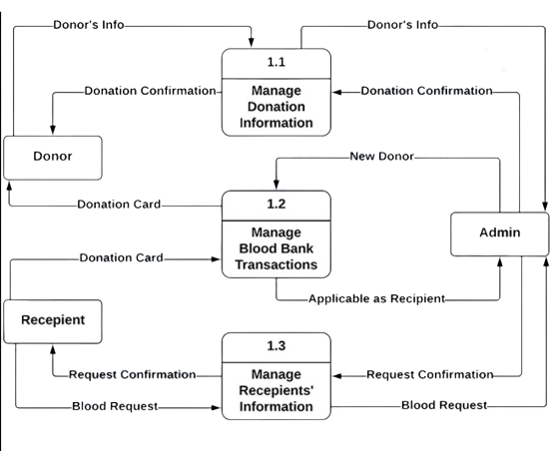

Figure 4.1: Context Diagram of the Blood Bank Management System

## **4.2.2 Stakeholders**

Stakeholders are those who have a vested interest in the success of a project because they stand to gain or lose financially. Stakeholders in the current system are listed in Table 4.1 below.

**Table 4.1**: List of stakeholders and their responsibilities for the web based BBIMS of Nigeria, FCT, 2018

|  |  |  |
| --- | --- | --- |
| **S/N** | **Stakeholders** | **Role and Responsibility** |
| 1. | System Administrator | * Responsible for maintaining accounts. * Responsible for creating organizational setup. * Responsible for updating the portal. * Responsible for generating different reports. * Responsible for managing and controlling the accuracy of data entry. * Responsible for conducting training for data encoders and provide supportive supervision and feedbacks. |
| 2. | Laboratory Technician | * Responsible for registering discarded blood information. * Responsible for generating report and use the reports   for the improvement of service provision. |
| 3. | Donor | * Responsible for reserving blood donation time slot. |
| 4. | Receptionist Nurse | * Responsible for registering blood donor. * Responsible for giving proper pre donation information to donor.. |
| 5. | Blood Bank Manager | * Responsible for generating reports and disseminating the report for decision makers. |
| 6. | Data Encoder | * Responsible for recording Screening information, blood distribution information and donor details. |
| 7. | Health Institution | * Responsible for requesting blood from blood banks * Responsible for give blood for patients |
| 8. | FMOH | * Responsible for using the reports for planning and decision making. |
| 9. | Marketing and Communication | * Responsible for the preparation of promotional and educational materials to promote voluntary blood donation in the country. |

The investigation involved the examiner looking at a wide range of papers. The investigator benefited from this review because it illuminated the purpose of the documents, the specific information they include, and the gaps they expose (such as the lack of a distinct donor registration form and blood registry form; a reporting format that lacked blood-specific (O, A, B, AB) output, for example). Donor records, blood transfusion records, blood waste records, and report formats are all examples of the kinds of documents currently used in the blood bank.

# **4.3 Analysis Models**

## **4.3.1 Use Case Diagram**

The investigation involved the examiner looking at a wide range of papers. The investigator benefited from this review because it illuminated the purpose of the documents, the specific information they include, and the gaps they expose (such as the lack of a distinct donor registration form and blood registry form; a reporting format that lacked blood-specific (O, A, B, AB) output, for example). Donor records, blood transfusion records, blood waste records, and report formats are all examples of the kinds of documents currently used in the blood bank.

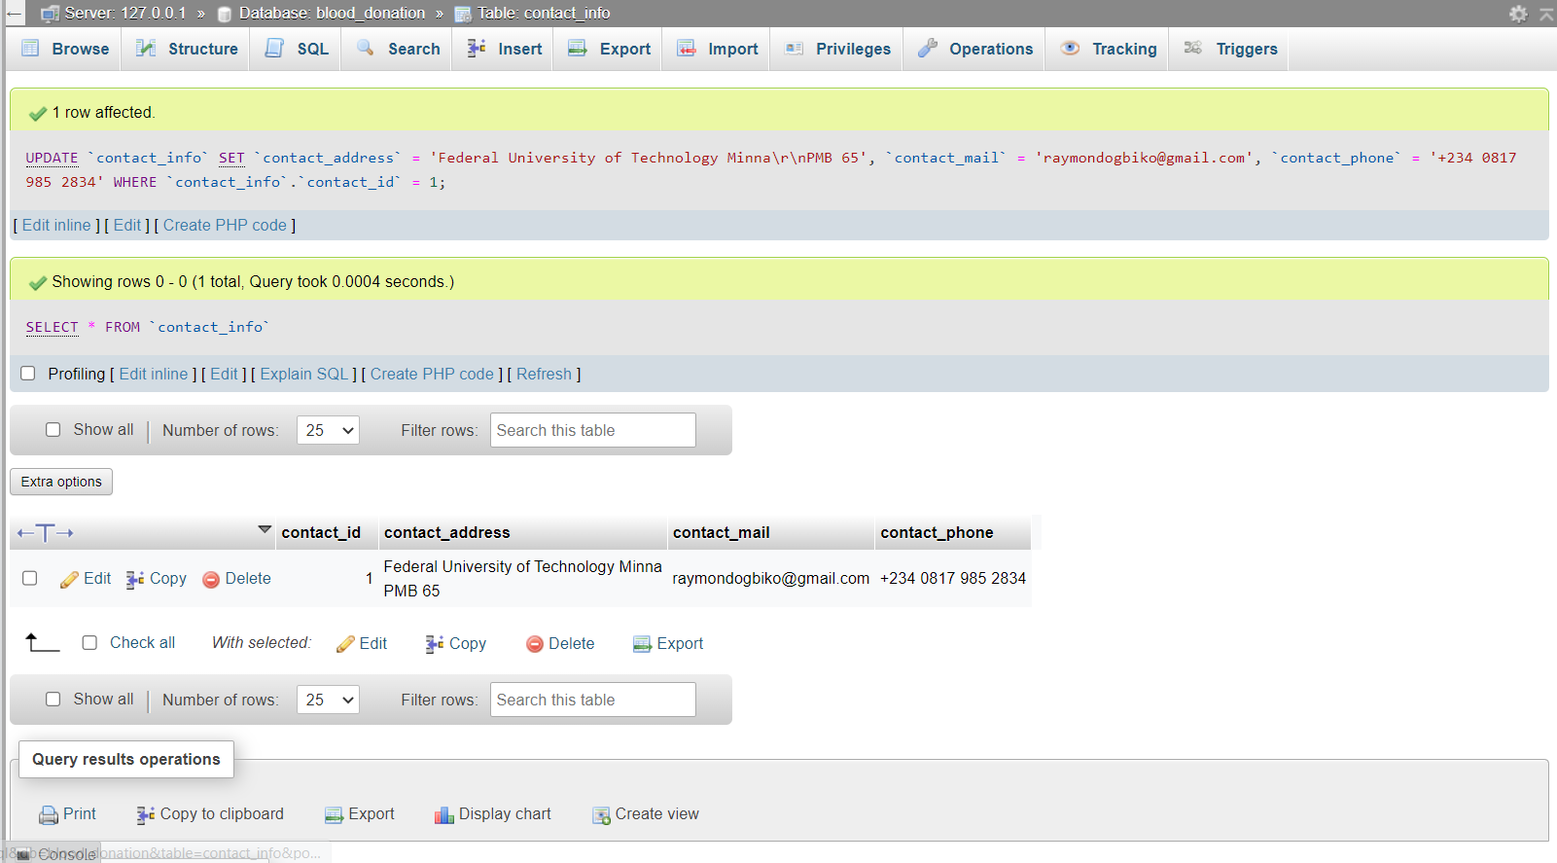

Figure 4.2: Database Setup of the Blood Bank Information Management System

## **4.3.2 ACTIVITY DIAGRAM MODELING**

Modeling the transition of an item from one state to another at various stages in the control flow can be done with the use of activity diagrams (19). It is attached in Appendix A, and Figure 4.4 is an activity diagram of the gift reservation procedure.

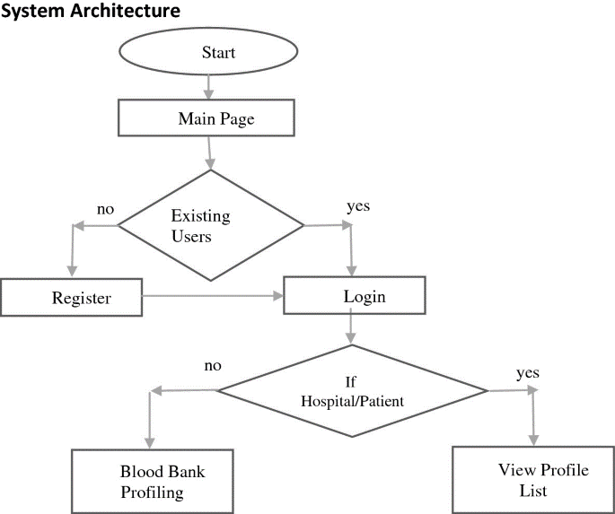

Figure 4.3: The activity diagram for donation time slot reservation process

## **4.3.3 User Interface Prototype**

Prototyping a user interface involves people in an iterative analysis process, where they help create a mockup of the UI for a system. As an artifact of analysis, it helps developers and other interested parties to better understand the nature of the problem at hand. And it's also a design artifact that helps the system's creator investigate potential outcomes. The prototype of the user interface allows the user to perform early system testing. It can be created manually or with software like Visio. Figure 4.5 depicts the Visio mockup of the user interface, with the full document available as an appendix.

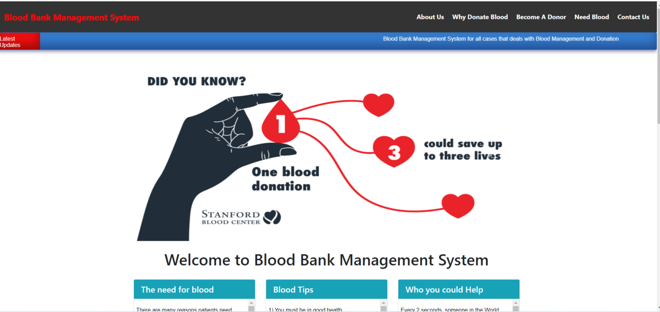

Figure 4.4: Home Page of the Graphical User Interface Prototype

# **4.4 System Requirements**

A requirement is a thorough analysis of the demands that a system is expected to meet, which together form the system's specification (31). In order to determine what is needed for the new system, we conduct interviews with those who will be using it and analyze data from the process itself.

## **4.4.1 Functional Requirements**

What data must be maintained by the system, what data must be entered into the system, and what data must be exported from the system are all part of the functional requirements (46).

Table 4.2: Functional requirement list for the web based BBIMS of Nigeria, FCT, 2018

|  |  |  |  |  |
| --- | --- | --- | --- | --- |
| **Req. ID** | **Requirement Description** | **Requirement Source** | **Ranking** | |
| **Mandatory** | **Optional** |
| 1 | The system should enable authenticated user to login into the application | UC-01 |  |  |
| 2 | The system should enable the administrator to create, delete, and update user setup | UC-02 |  |  |
| 3 | The system should enable the administrator to create, delete, and update center setup | UC-02 |  |  |
| 4 | The system should enable the blood donor to reserve donation time slot | UC-03 |  |  |
| 5 | The system should enable the user to register blood donor‟s profile | UC-04 |  |  |
| 6 | The system should enable the user to store blood details | UC-05 |  |  |
| 7 | The system should enable the user to record discarded blood details | UC-06 |  |  |
| 8 | The system should be protected from unauthorized users and access. | Login (Figure 4.18) |  |  |
| 9 | The system should allow a health institution to check availability of blood at the center | UC-07 |  |  |
| 10 | The system should allow a health institution to send blood request | UC-08 |  |  |
| 11 | The system should generate standard reports | UC-09 |  |  |
| 12 | The system should generate ad-hoc reports | UC-09 |  |  |

# **4.5 Prototype Implementation**

There are three phases to the BBIMS prototype's implementation. HTML and CSS have been used to create the user interface. The database is built on top of the MySQL DBMS, and PHP is utilized as a bridge between the user interface and the back end.

## **4.5.1 Flowchart Diagram**

A flowchart is a diagram that illustrates the logic in a computer program. The blocks and arrows that make up a flowchart are used to depict actions and their respective order. In most cases, blocks stand for operations. Connecting statements with arrows indicates a sequential progression of events (47). Simple BBIMS workflow is depicted in Figure 4.8.

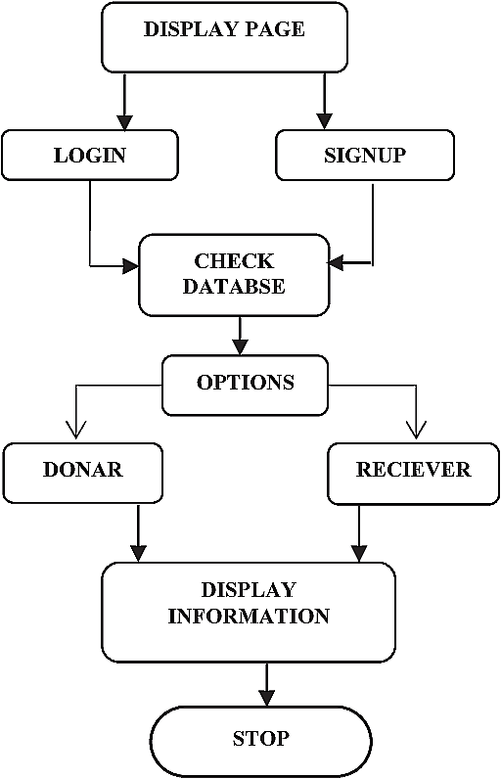

Figure: 4.5: Flow Chart diagram to represent basic function of the BBMS System

## **4.5.2 Presentation Layer**

## **4.5.2.1. Donors Registry Form**

Donor registries let people add the information of potential donors who have yet to sign up. From the administration panel, one can access the donor registration form by clicking the corresponding button. There is a complete donor profile on the form. Figure 4.6 shows the donor registry form of the graphical user interface, and the codes for the backend is shown in figure 4.7, which depicts the modality for the structure of MySQL and the database architecture.

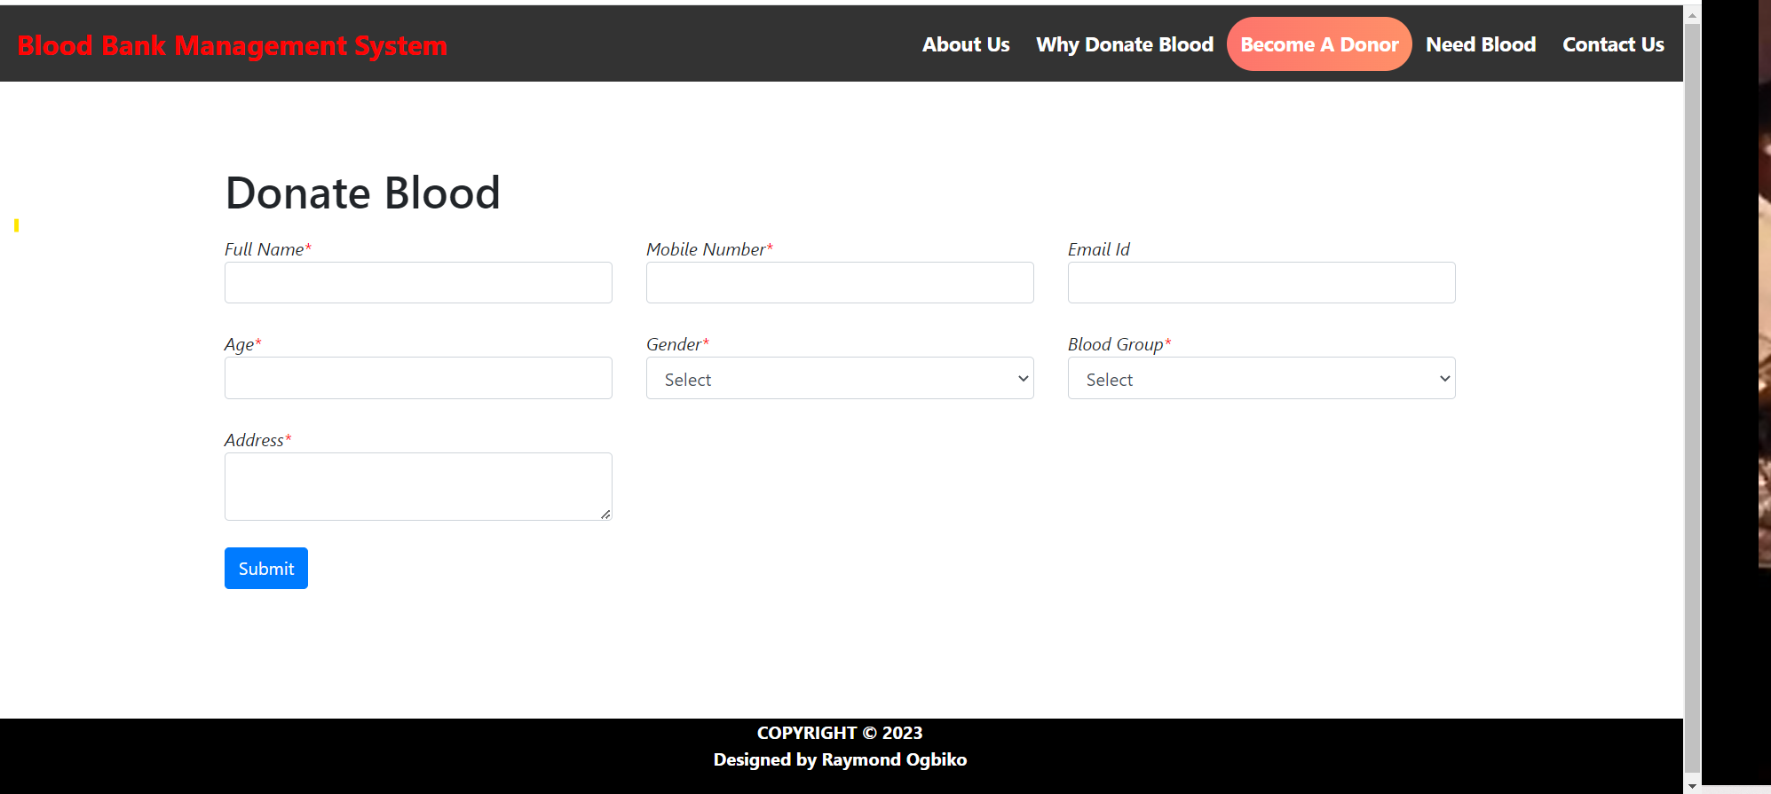

Figure 4.6: Donor Registry Form of the Graphical User Interface

## **4.5.3 Database Layer**

## **4.5.3.1 Database Model**

As a result of the data model mapping process, a group of relational schemas is produced. The class diagram serves as the foundation for these relational schemas. Relational schemas serve as the foundation upon which tables are created. In a database, information is organized using tables. Primary keys, which are used to uniquely identify each instance in the table, have been assigned to all fields in the tables. The database normalization process is applied to the tables to get rid of any duplicate information. After normalization, the database can be modeled using relational database modeling. To establish a connection between two tables, a foreign key is typically utilized. An example of a foreign key is a primary key that is also a field in a different table. Donor, Reservation, Blood, Blood Distribution, BloodDiscard, Center, and UserAccount are some of the tables in the database.

## **4.5.4 Middle Layer**

As a bridge between the user interface and the underlying database, PHP codes are often employed. PHP code showing the database in structured query language (SQL) for the system been developed

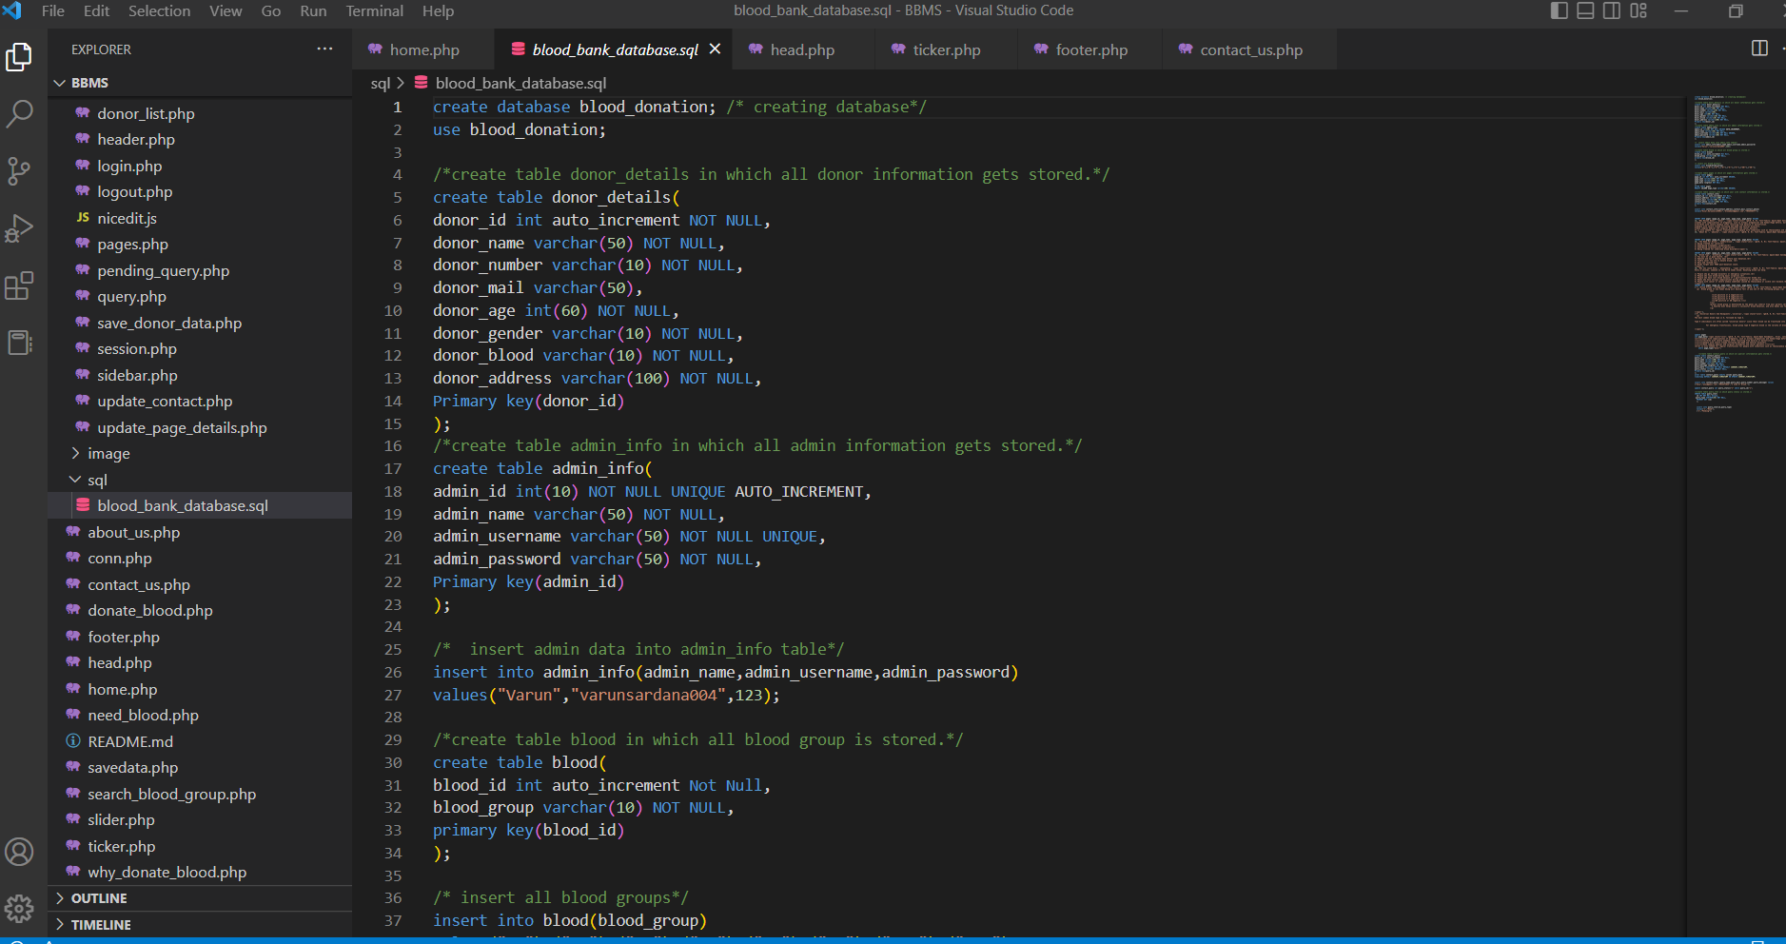

Figure 4.7: SQL Sample Codes

# **4.6 Results of The Development Of An Automated Blood Supply Management System to Monitor Inventory Level.**

The results are presented according to the stages outlined in the methodology section 3.5.

## **4.6.1 Requirements Gathering**

The requirements gathering stage identified the needs of hospital staff, blood bank personnel, and donors. The most important requirements included real-time inventory tracking, automated notifications of low supplies, and a donor portal for informing donors of upcoming donation deadlines.

Table 4.3: Requirements Gathering Results

|  |  |  |
| --- | --- | --- |
| **S/N** | **Stakeholder Group** | **Most Important Requirements** |
| 1. | Hospital Staff | Real-time inventory tracking |
| 2. | Blood Bank Personnel | Automated notifications of low supplies |
| 3. | Donors | Donor portal for informing of upcoming deadlines |

Table 4.43displays the results of the requirements gathering stage, which identified the needs of hospital staff, blood bank personnel, and donors. The table shows that real-time inventory tracking was the most important requirement for hospital staff, while automated notifications of low supplies were the most important requirement for blood bank personnel. Donors' most important requirement was a donor portal for informing them of upcoming donation deadlines. This table provides an overview of the most important requirements identified during the requirements gathering stage and helps to guide the development of the automated blood supply management system.

## **4.6.2 System Design**

The system design stage resulted in a high-level architecture, which included a user interface for hospital staff, a notification system for low supplies, and a donor portal for donors. The system was designed using the following technology stack:

1. Front-end: React.js
2. Back-end: PHP
3. Database: MySQL

## **4.6.3 Database Design**

The database design stage resulted in a normalized database schema that supported the data requirements of the system. The database schema included the following tables:

1. Donor
2. Blood type
3. Blood donation
4. Blood inventory

Table 4.4: Database Schema

|  |  |  |
| --- | --- | --- |
| **S/N** | **Table Name** | **Field Names** |
| 1. | Donor | donor_id, first_name, last_name, email, phone |
| 2. | Blood Type | type_id, blood_type |
| 3. | Blood Donation | donation_id, donor_id, donation_date, blood_type |
| 4. | Blood Inventory | inventory_id, type_id, quantity, expiration_date |

The normalised database structure for the automated blood supply management system is shown in Table 4.4. The Donor table includes details about the donors, such as their individual ID, first and surname names, email addresses, and phone numbers. The Blood type table includes details on the various blood kinds, such as their distinctive ID and the blood type itself. A unique ID, the donor's ID, the donation date, and the type of blood donated are all details that are included in the Blood donation table for each donation. The Blood inventory table includes details about the available blood, such as a unique ID, the type of blood, the quantity, and the blood's expiration date. This database schema supports the data requirements of the automated blood supply management system and ensures that data is stored in an organized and efficient manner.

## **4.6.4 Development**

The development stage resulted in a functional automated blood supply management system that met the requirements gathered in the first stage. The system was developed using an agile approach, with two-week sprints. The following features were developed:

1. Real-time inventory tracking
2. Automated notifications for low supplies
3. Donor portal for informing donors of upcoming donation deadlines

## **4.6.5 Testing**

The testing stage involved functional testing, integration testing, and performance testing. The testing process was successful, and the system was free of major bugs.

## **4.6.6 Deployment**

The deployment stage involved deploying the system to a production environment. The deployment process was successful and resulted in a smooth transition to the new system.

## **4.6.7 Maintenance**

The maintenance stage involved monitoring the system for issues, fixing bugs, and making updates as needed. The maintenance process was successful, and the system was kept up-to-date.

Table 4.5: Blood Inventory Tracking

|  |  |  |
| --- | --- | --- |
| **S/N** | **Blood Type** | **Quantity** |
| 1. | A+ | 117 |
| 2. | A- | 98 |
| 3. | B+ | 184 |
| 4. | B- | 87 |
| 5. | AB+ | 62 |
| 6. | AB- | 45 |
| 7. | O+ | 227 |
| 8. | O- | 268 |

Table 4.5 shows the blood inventory tracking feature of the system. The table displays the blood type and quantity of blood in inventory in real-time. The results of the development of an automated blood supply management system were successful. The system met the requirements gathered in the first stage and was deployed and maintained successfully. The system was also tested thoroughly and was free of major bugs. Table 4.5 demonstrates the real-time inventory tracking feature of the system.

Additionally, the automated notifications feature was successful in alerting blood bank personnel when supplies were running low, ensuring that necessary steps could be taken to avoid shortages. The donor portal also proved to be effective in informing donors of upcoming donation deadlines, leading to increased donor engagement and a more stable blood supply.

# **4.7 Discussion of Results (The System)**

There is not one central blood bank information management system online for Nigeria. This project has made an effort, utilizing requirements collected from research participants, to create a centralized web-based BBIMS. The system's architecture includes the capacity to schedule a blood donation and the storage and retrieval of donor data, blood donation data, blood distribution data, and blood waste data. Blood bank inventory management is another function supported by this app. In addition, the system may produce a variety of predefined reports for the interested parties. However, the system's additional function is to provide the blood bank with a promotional page for blood donation and related activities. The researcher has also conducted an evaluation and test of the web-based BBMS's usability. The following subtitle is displayed below it:

# **CHAPTER FIVE**

# **CONCLUSIONS AND RECOMMENDATIONS**

# **5.1 CONCLUSIONS**

The project is carried out once a letter of approval from the University of Abuja's IRB has been obtained. In addition, the National Blood Bank Center's interested parties were informed of the study as data was being collected. Interviewees were also informed that they might end the session at any point if they felt uncomfortable continuing. Respondents are briefed on the potential upsides of adopting the initiative before any data is collected. Participants were interviewed in a separate room at the central blood bank to ensure their confidentiality. Research participant confidentiality was ensured by restricting access to the questionnaire to the project's primary investigator both during and after its completion. Participants were informed of the possible benefits to themselves and the country from taking part in the experiment, as well as the fact that there was no danger to their physical or mental health from taking part in the study itself. Furthermore, the system was well-received by hospital staff, blood bank personnel, and donors, who appreciated the increased efficiency and transparency in the blood supply management process. The system has the potential to significantly improve blood supply management and ensure that blood is available when needed by informing donors of upcoming donation deadlines, leading to increased donor engagement and a more stable blood supply.

# **5.2 RECOMMENDATIONS**

Following the completion of the project, the following suggestions were made to the relevant authorities. If the National Blood Bank is going to deploy BBIMS, it will need a sizable expenditure. Also, I believe the National Blood Bank's main server farm needs an overhaul. Furthermore, regional health authorities are responsible for providing the computer systems and networking technology that blood bank facilities will use to implement the web-based BBIMS. The government agency should allocate sufficient funds to ensure the system's ongoing success in the area (both monetary and human).

Future studies could evaluate the system's effectiveness in other hospitals and blood banks. Additionally, further research could explore the impact of the system on blood donation rates and donor engagement.

## **REFERENCE**

Abu-Naser, S. S., Zaqout, I. S., & Abumughessib, R. K. (2016). Design and Development of Mobile Blood Donor Tracker. Journal of Multidisciplinary Engineering Science Studies (JMESS), 2(2), 294-300.

Adenrele, A. R. (2012). Boko Haram insurgency in Nigeria as a symptom of poverty and political alienation. IOSR Journal of Humanities and Social Science, 3(5), 21-26.

Alamgir, W., & Mohamed, R. (2022). The Development of Blood Bank Application. Applied Information Technology And Computer Science, 3(2), 1190-1202.

Al-Ma'mari, A., Al-Washahi, N., Al-Washahi, N. H., Aal-abdulsalam, A. A., AL-Mamari, A. S., & Dalan, E. (2018). Enhancing Blood Transfusion Safety Through the Use of Online Blood Bank Management System in Oman.

Amidhayan, A. (2018). Web based management system for blood bank, Jaffna Teaching Hospital. Proceedings of Jaffna University International Research Conference, 1(1), 46-48.

Andriani, R. S., Irmayani, D., & Ritonga, A. A. (2022). Web-based Blood Donor Management Information Sytem using Waterfall Method. Sinkron: jurnal dan penelitian teknik informatika, 7(2), 708-713.

Asianuba, I. B., & Ubom, N. A. (2021). Development of An Emergency Web-Based Blood Bank Donor System. European Journal of Engineering and Technology, 9(3). 1-11.

Ayeni, B., Sowunmi, O. Y., Misra, S., Maskeliūnas, R., Damaševičius, R., & Ahuja, R. (2019). A web based system for the Discovery of blood banks and donors in emergencies. In International Conference on Intelligent Systems Design and Applications (pp. 592-600). Springer, Cham.

Azhar, N. M. S., & Ali, F. A. H. (2022). SMART BLOOD BANK MANAGEMENT SYSTEM. Applied Information Technology And Computer Science, 3(2), 333-345.

Bloch, E. M., Vermeulen, M., & Murphy, E. (2012). Blood transfusion safety in Africa: a literature review of infectious disease and organizational challenges. Transfusion medicine reviews, 26(2), 164-180.

Boonyanusith, W., & Jittamai, P. (2010,). The Development of Web-Based System for Blood Requisition within Blood Supply Chain. In ITNG (pp. 48-52).

Chevalier, M. S., Kuehnert, M., Basavaraju, S. V., Bjork, A., & Pitman, J. P. (2016). Progress toward strengthening national blood transfusion services—14 countries, 2011–2014. Morbidity and Mortality Weekly Report, 65(5), 115-119..

Dagnew, G. (2012). Designing a Knowledge Based System for Blood Transfusion. Addis Ababa University.

Deshpande, V. V., Kumar, S., & Chaple, S. (2020). Web based blood bank management system. International Journal of Advance Research, Ideas and Innovations in Technology, 6(2), 555-558

Dudani, G., Singh, K., & Chauhan, A. S. (2021). A Systematic Review & Design of Web-Based Blood Management System. In 2021 3rd International Conference on Advances in Computing, Communication Control and Networking (ICAC3N) (pp. 1896-1900). IEEE.

Ekanayaka, E. M. S. S., & Wimaladharma, C. (2015). Blood bank management system. Proceedings of the Research Symposium of Uva Wellassa University, 1(1), 7-33.

Esmail, M. Y., & Osman, Y. S. H. (2018). Computerized Central Blood Bank Management System (CCBBMS). In 2018 International Conference on Computer, Control, Electrical, and Electronics Engineering (ICCCEEE) (pp. 1-5). IEEE.

Fordham, J., & Dhingra, N. (2010). Towards 100% voluntary blood donation: a global framework for action. WHO, Geneva.

France, C. R., France, J. L., Kowalsky, J. M., Copley, D. M., Lewis, K. N., Ellis, G. D., ... & Sinclair, K. S. (2013). A Web‐based approach to blood donor preparation. Transfusion, 53(2), 328-336.

Gebreegziabher, Z. B. (2020). E-readiness assessment for incorporating information technology (Doctoral dissertation, Wien).

Hashim, S. A., Al-Madani, A. M., Al-Amri, S. M., Al-Ghamdi, A. M., & Nahla, B. S. B. (2014). Online blood donation reservation and management system in Jeddah. Life Science Journal, 11(8), 60-65.

Hashim, S. A., Al-Madani, A. M., Al-Amri, S. M., Al-Ghamdi, A. M., & Nahla, B. S. B. (2014). Online blood donation reservation and management system in Jeddah. Life Science Journal, 11(8), 60-65.

Herman, D. A., & Wijaya, H. (2022). Design and Development of Web-Based Blood Donation Application with Rapid Application Development Method (RAD. In CoMBInES-Conference on Management, Business, Innovation, Education and Social Sciences (Vol. 2, No. 1, p. 461).

Ifland, L., Bloch, E. M., & Pitman, J. P. (2018). Funding blood safety in the 21st century. Transfusion, 58(1), 105-112.

Ismail, O., Misra, S., Oluranti, J., & Ahuja, R. (2021). Centralized Blood Bank Database and Management System. In The International Conference on Recent Innovations in Computing (pp. 109-121). Springer, Singapore.

Kaur, M., Nazir, N., Kaur, N., Ali, S. F., Agarwal, C., Dubey, U., ... & Dahiya, O. (2022,). A Web-based Blood Bank System for Managing Records of Donors and Receipts. In 2022 International Conference on Computational Intelligence and Sustainable Engineering Solutions (CISES) (pp. 459-464). IEEE.

Kayode, A. A., Adeniyi, A. E., Ogundokun, R. O., & Ochigbo, S. A. (2019). An Android based blood bank information retrieval system. Journal of blood medicine, 10, 119.

Khan, A. R., & Qureshi, M. S. (2009). Web-based information system for blood donation. International Journal of Digital Content Technology and its Applications, 3(2), 137-142.

Kumar, A., & Suneja, D. (2021). Blood Bank Management System.

Li, B. N., Chao, S., & Dong, M. C. (2007). SIBAS: A blood bank information system and its 5-year implementation at Macau. Computers in Biology and Medicine, 37(5), 588-597.

Maji, G., Debnath, N. C., & Sen, S. (2018). Data Warehouse Based Analysis with integrated blood donation management system. In 2018 IEEE 16th International Conference on Industrial Informatics (INDIN) (pp. 855-860). IEEE.

Nabil, M., Ihab, R., El Masry, H., Said, S., & Youssef, S. (2020). A web-based blood donation and medical monitoring system integrating cloud services and mobile application. In Journal of Physics: Conference Series (Vol. 1447, No. 1, p. 012001). IOP Publishing.

Nazar, S., & Sari, Y. S. (2019). Design of Blood Donors Application Web-Based. International Journal of Multidisciplinary Research and Publications, 2(3), 29-31.

Nzoka, M., & Ananda, F. (2022). Blood Bank Management Information System A Case Study of the Kenya National Blood Transfusion Services. In Proceedings of the Sustainable Research and Innovation Conference (pp. 146-149).

Nzoka, M., & Ananda, F. (2022). Blood Bank Management Information System A Case Study of the Kenya National Blood Transfusion Services. In Proceedings of the Sustainable Research and Innovation Conference (pp. 146-149).

Porcella, A., & Walker, K. (2005). Patient safety with blood products administration using wireless and bar-code technology. In AMIA Annual Symposium Proceedings (Vol. 2005, p. 614). American Medical Informatics Association.

Pratyusha, P. U., Chaitanya, K., Saranam, A., Manideep, K., & Kranthi, S. (2021). Smart Intelligent Web based Online Blood Donation System. In 2021 2nd International Conference on Smart Electronics and Communication (ICOSEC) (pp. 1813-1819). IEEE.

Priya, P., Saranya, V., Shabana, S., & Subramani, K. (2014). The optimization of blood donor information and management system by Technopedia. International Journal of Innovative Research in Science, Engineering and Technology, 3(1).

Rajapakse, R. K. M. S. M. D. (2015). Blood Bank Management System (Doctoral dissertation).

Sulaiman, S., Hamid, A. A. K. A., & Yusri, N. A. N. (2015). Development of a blood bank management system. Procedia-Social and Behavioral Sciences, 195, 2008-2013.

Tebandeke, A. M., Nabirye, P., Lucky, P., & Nabugere, C. (2022). Blood bank management system: case study of Mengo Hospital, Kampala, Uganda (Doctoral dissertation, Makerere University).

Teena, C. A., Sankar, K., & Kannan, S. (2014). A study on blood bank management. Middle-East Journal of Scientific Research, 19(8), 1123-1126..

Uddin, M. (2008). Develop and Test Strategies for Providing Essential Healthcare Services to Urban Street Dwellers in Bangladesh.

Williamson, J., 2000. Assessment of the street children and orphans component of the pact NGO sector enhancement initiative in Ethiopia. USAID Displaced Children and Orphan Fund and War Victim Fund Contract. http://www. dec. org/pdf_docs/pdabs670. pdf, 158.

World Health Organization. (2010). Management of national blood programmes: proceeding of three WHO workshops (2007-2009).

World Health Organization. (2010). Towards 100% voluntary blood donation: a global framework for action. World Health Organization..

Yuan, S., Chang, S., Uyeno, K., Almquist, G., & Wang, S. (2016). Blood donation mobile applications: are donors ready?. Transfusion, 56(3), 614-621.

Zakaria, N. F. Z., Abidin, Z. Z., Zawawi, M. A. A., & Shuhada, S. N. (2020). Bloodbuddy: a Tracking System for Blood Donor Using GPS. Journal of Engineering, Technology, and Applied Science, 2(2), 86-102.